**OpenTag3 Quick Start Manual**

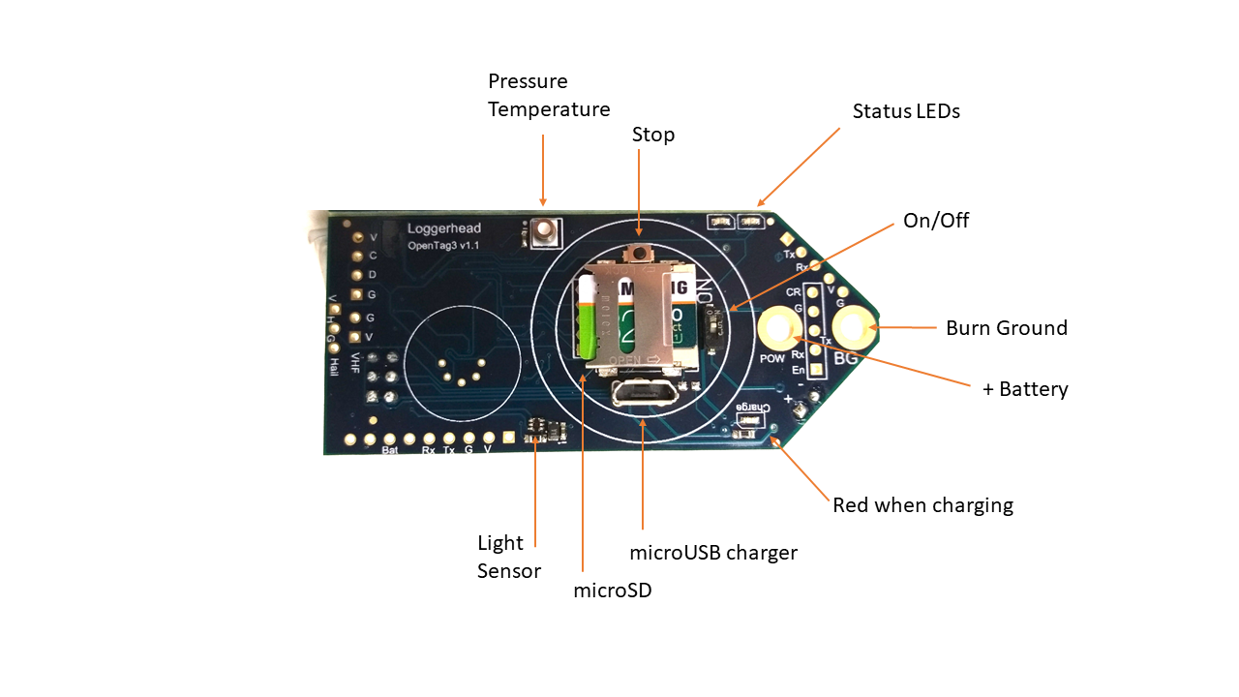

**1. Setting the Time**

The time is set from a script file named setup.txt that is saved to the microSD card. (see format details below). The time on the OpenTag3 will be set when the power switch is turned on.

The current time will be retained (even with the power dip switch off).

**2. Starting Record**

Insert the microSD card in the recorder. The card holder is flip top: slide and flip.

To start recording, slide the dip switch to the ON position. The recorder will set the time if present in the default.txt file and start recording.

The hour set on the board will be indicated by turning the red LED on, and flashing the green LED the number of hours the clock is set to. So, if the clock is 12:30, the green LED will flash 12 times at the start.

**3. Ending Record**

Press and hold the Stop button until the LED turns solid red. Then turn off the power switch. If the DIP switch is not turned off in 30 seconds, recording will resume.

The battery should remain connected to the board so that the clock retains the current time. Current draw is very low to retain the clock time.

**OpenTag Script File**

**Create with a text editor, like Notepad.**

**The file MUST be named setup.txt**

**The Date and Time format is YY-MM-DD hh:mm:ss**

**Example File**

//Open Tag Script File

// Set Date and Time

TM 18-09-17 18:08:00

// Indicate lines that are comments. Any line with // will be ignored

This will set the time to September 17, 2018, 18:08:00

**setup.txt Commands**

|  |  |  |
| --- | --- | --- |
| **Command** | **Function** | **Example** |
| TM | Sets time | TM 17-01-15 12:05:00 |
| LD | Disables LEDS | LD |
| AG | Accelerometer scaling (2, 4, 8, 16) default: +/- 16 g | AG 8 //set accelerometer full scale to +/- 8g |
| BW | Burn Wire Time Set | BW 17-01-15 16:30:00 |
| BM | Burn minutes. Sets number of minutes from start to initiation burn. This is preferred because it does not require the time to be set correctly. | BM 60 // start burn in 60 minutes |
| RD | Record Duration (s). Sets file length. Default: 3600 s | RD 600 // record 600 s (10 minute) files |

TM: Sets time. Time will be set to this time when the tag is turned on. Format is YY-MM-DD hh:mm:ss

This line is automatically commented when it runs, so that the time will only be reset once. It will not reset if the tag is turned off and back on again.

LD: Disable LEDs. Will disable LEDs during file writing.

BW: Sets time burn wire will be energized. When the burn wire is activated the burn wire circuit is connected, and the burn wire sees the output of the battery directly. Requires an OpenTag with the burn wire connected. Format is YY-MM-DD hh:mm:ss

BM: Sets the burn wire to be energized a specified number of minutes after the tag is turned on. This method is preferred, because it does not require the clock to be set correctly.

RD: Sets file duration in seconds. Default is 3600 s (1 hour). There is a short gap in between files as one file is closed and a new one is opened.

**Tips about Sensor Calibration**

All of the sensors used on OpenTag are digital, in that they have their own analog-to-digital converter. The values stored by OpenTag are calibrated using the calibration values supplied in the technical specification sheets. This is our way of saying....they could be off.

**Accelerometer and Gyroscope Calibration:**

Place device in a known orientation for a few seconds when recording starts. Generally a flat surface is a good idea. These readings can then be later used to compensate for offsets in the accelerometer and gyroscope values. We have noticed offsets in the Z direction of a few percent. When the tag is laying flat, you should get 1 g of acceleration (or -1 g depending on the orientation of the board).

**Magnetometer Calibration:**

The purpose of the magnetometer calibration is to record data from all possible orientations. This is used to correct for offsets in the magnetometer due to nearby metals. For the first recording, rotate the device in all possible orientations (both horizontally and vertically). Put on some LMFAO and do some shufflin'. These data can be used to determine the offset caused by nearby metals in post-processing.

**Sample Rates**

The accelerometer, magnetometer, and gyroscope are sampled at 50 Hz.

The light, pressure, temperature, and battery voltage are sampled at 1 Hz.

**Data Files**

Data files are stored in CSV format.

The accelerometer, magnetometer, and gyroscope data are stored as 16-bit integers ranging from -32768 to 32767. They must be scaled to convert them into appropriate units.

Red, green, and blue are 16-bit light level values that must be scaled to convert to appropriate units.

Pressure is stored as mBar and depth.

Temperature is stored as degrees Celsius.

Spin is counts per second if an optional Hall sensor and impeller are used with the tag.

V is voltage of the battery.

**Time stamps**

The date and time of the real-time clock is stored to the column labeled date.

**Loading CSV Files with MATLAB**

**Required m-files**

**ot_load.m: Loads OpenTag files and applies calibration coefficients.**

**oDSG.m: Called by ot_load to read the OpenTag files.**

**ot_plot.m: Plots data after loading with ot_load**

From MATLAB command prompt type:> ot_load

In the first dialog box, select the file to load.  
In the second dialog box, select the calibration file named PRESSTMP.CAL

The MATLAB code **DOES NOT CORRECT** for hard iron offsets or offsets on the accelerometer or gyroscope.

**Example output from ot_load**

**Data are plotted in three columns for X, Y, Z. Rows are accelerometer, magnetometer, and gyroscope.**





**Charging**

The lithium battery can be charged while it is connected to the OpenTag board through the microUSB connector next to the flash card holder.

Plug in the microUSB cable to a computer and the other end into the to the OpenTag board.

When charging the red LED will be on. When charging is complete the LED will turn off. Charging will typically take less than 5 hours.